**Setting Up Prometheus**

Step-1: You can clone the YAML files form **Github**.

<https://github.com/linuxacademy/content-kubernetes-prometheus-env>

# git clone <https://github.com/linuxacademy/content-kubernetes-prometheus-env>

Step-2: # cd content-kubernetes-prometheus-env

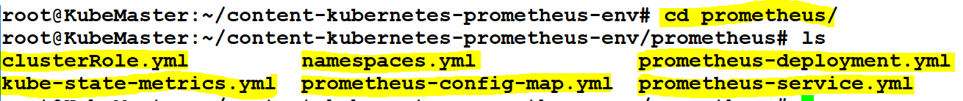

1. Open a file called “namespace.yml”. This file will be used to create the monitoring namespace.

# vi namespace.yml

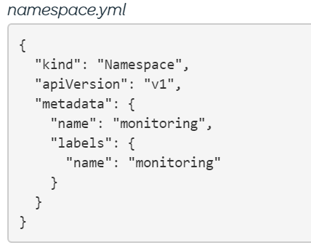

1. Apply the namespace file.

# kubectl apply -f namespace.yml

1. Open “prometheus-config-map.yml” file. Kubernetes will use this file to manage the Prometheus.yml configuration file.

Note: we must add ip address of nodes in node-export section with 9090 port no.

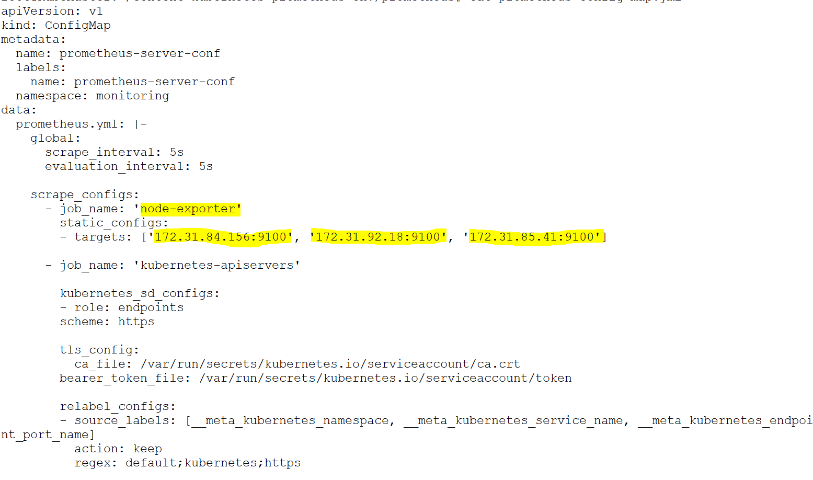

1. Create the ConfigMap.

# kubectl apply -f config-map.yml

1. open “prometheus-deployment.yml”. This file will be used to create the Prometheus deployment; which will include the pods, replica sets and volumes.

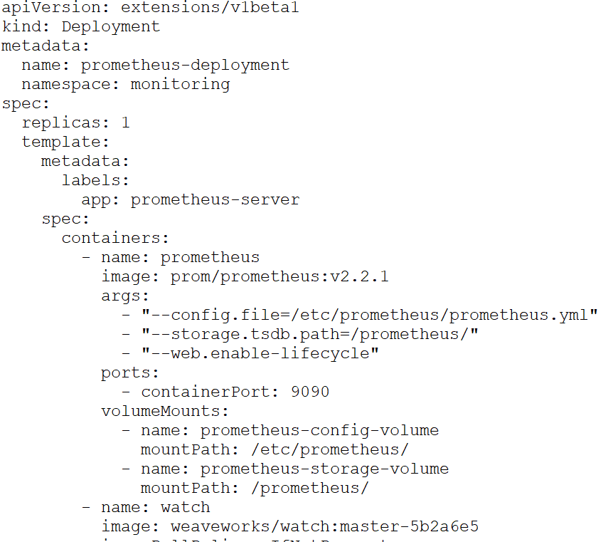

1. Deploy the Prometheus environment:

# kubectl apply -f prometheus-deployment.yml

1. Finally, we will finish off the Prometheus environment by creating a server to make publicly accessible. Create prometheus-service.yml.

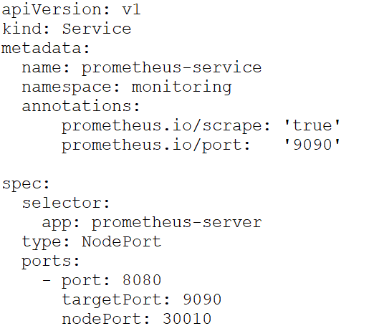

1. Create the service that will make Prometheus publicly accessible:

# kubectl apply -f prometheus-service.yml

1. Open a file called clusterRole.yml. this will be used to set up the cluster’s roles.

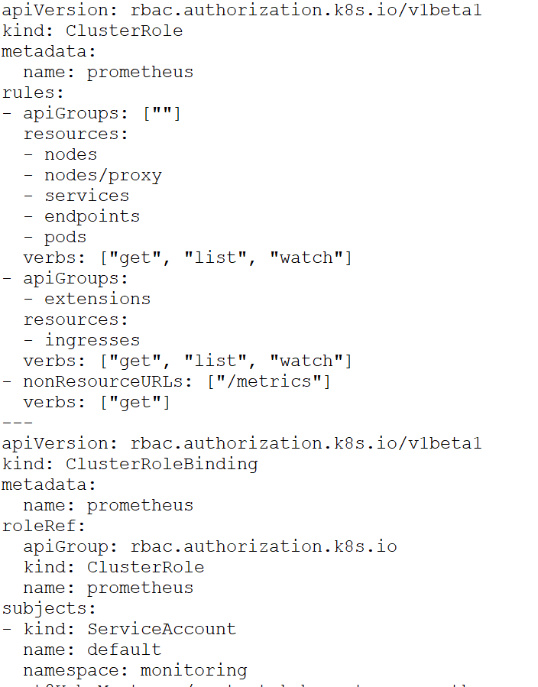

1. Apply the cluster roles to the Kubernetes cluster:

# kubectl apply -f clusterRole.yml

1. Crate the Kube State Metrics pod to get access to metrics on the Kubernetes API:

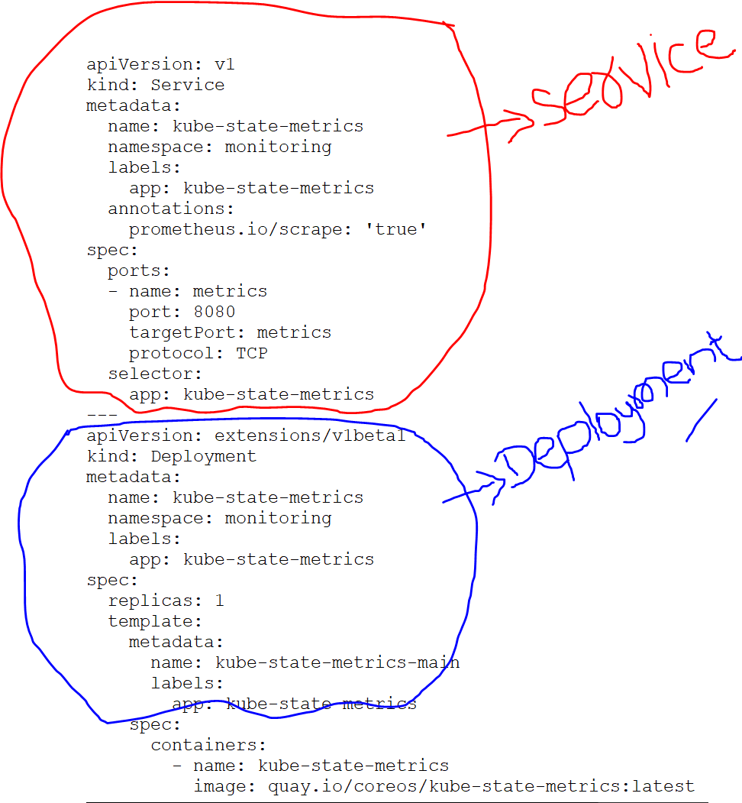

1. Apply the kube-state-metrics.yml

# kubectl apply -f kube-state-metrics.yml

Note: Now Access Prometheus by visiting https://<MASTER_IP>:30010

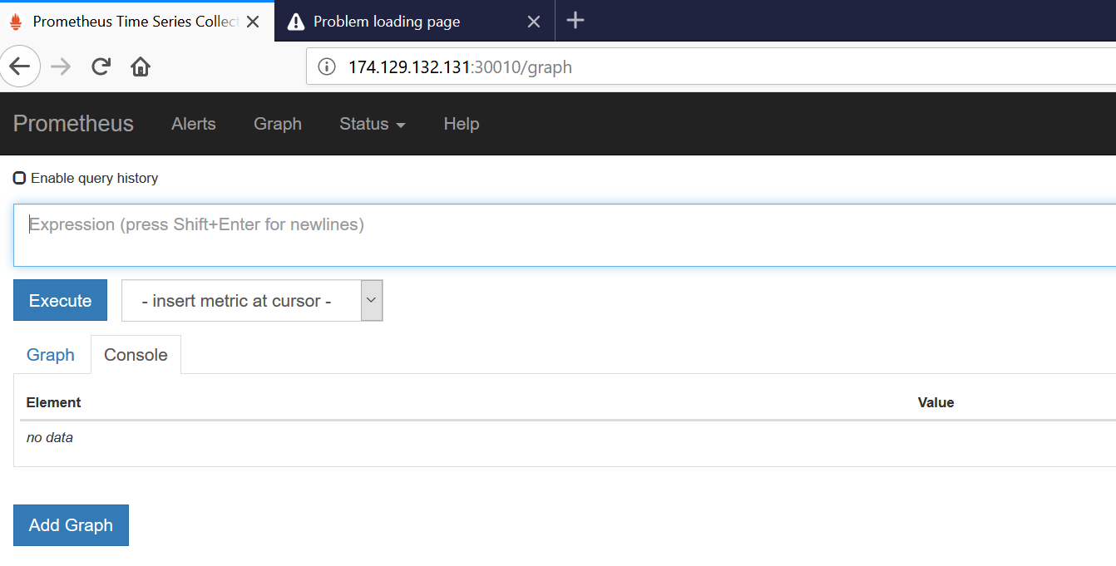

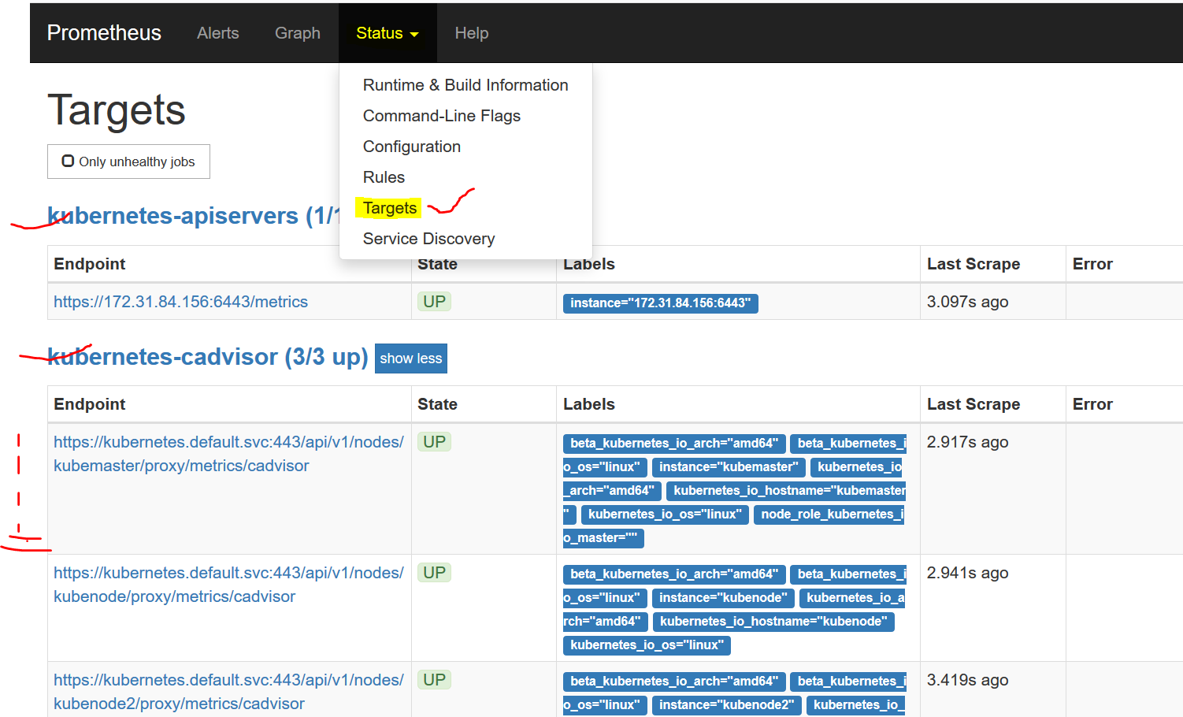

**Setting Up Grafana**

* deploy a Grafana pod and service to Kubernetes

Step-3:

1. Open grafana-deployment.yml. This file will be used to create the Grafana deployment. Be sure to change the password.

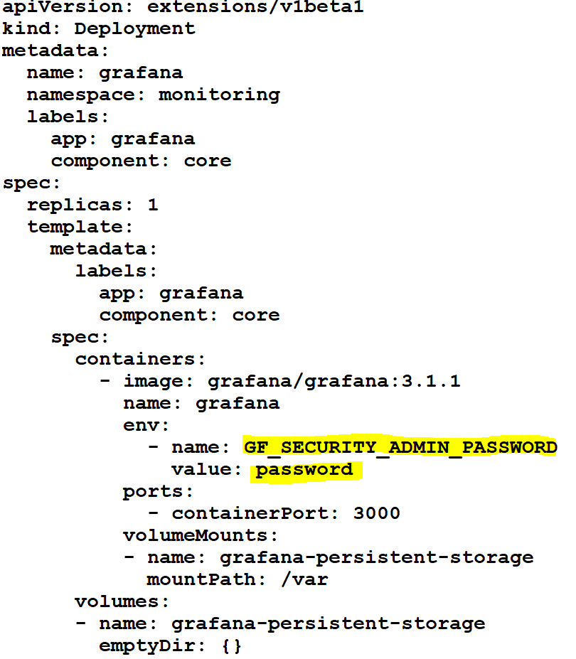

* Create Grafana deployment .

# kubectl apply -f grafana-deployment.yml

1. Open grafana-service.yml. This file will be used to make the pod publicly accessible.

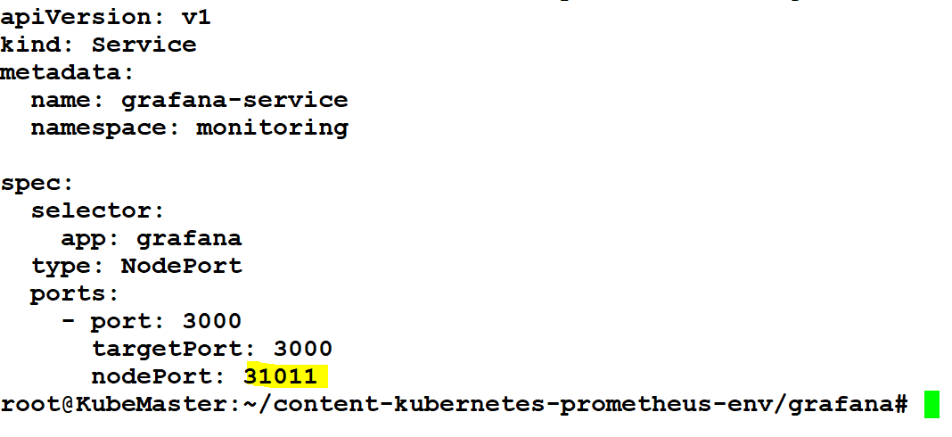

* Create Grafana service .

# kubectl apply -f grafana-service.yml

* Now Access Grafana Dashboard by visiting https://<MASTER_Public_IP>:31011

User_Name: admin and Password: password.

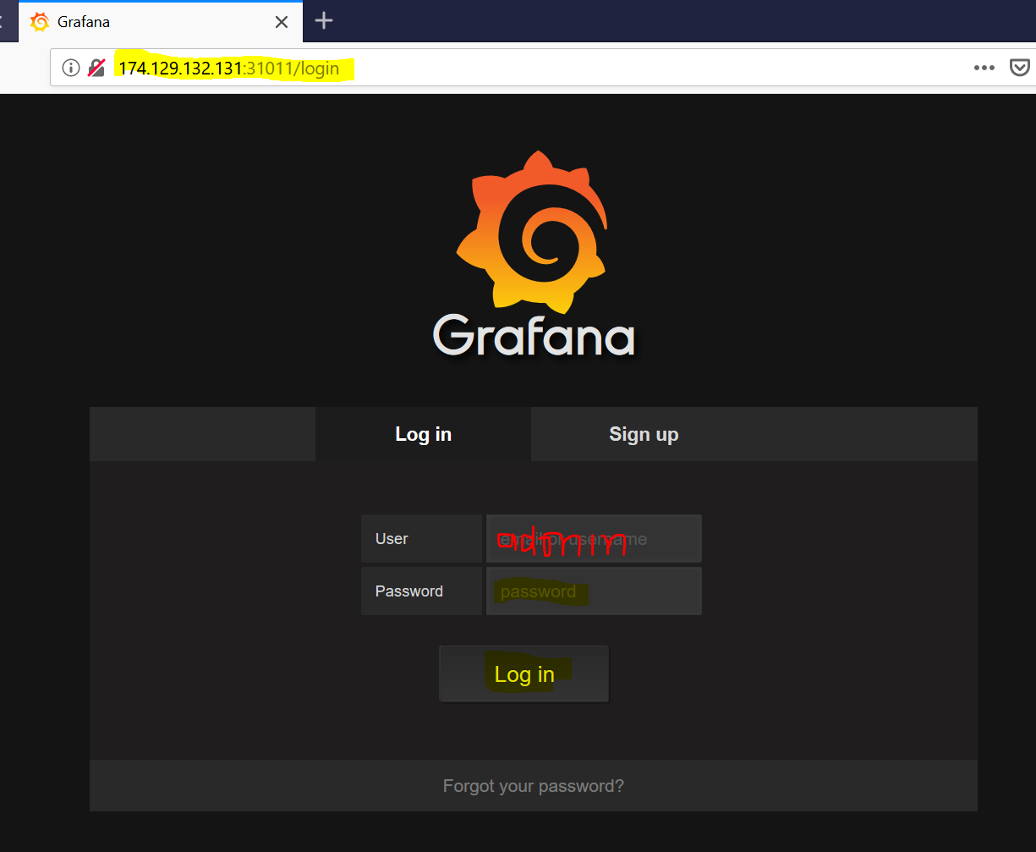

Step-4: Now add DataSource on Grafana Dashboard.

Go to menu bar 🡪 click on “DataSource” 🡪 click on “Add data source”

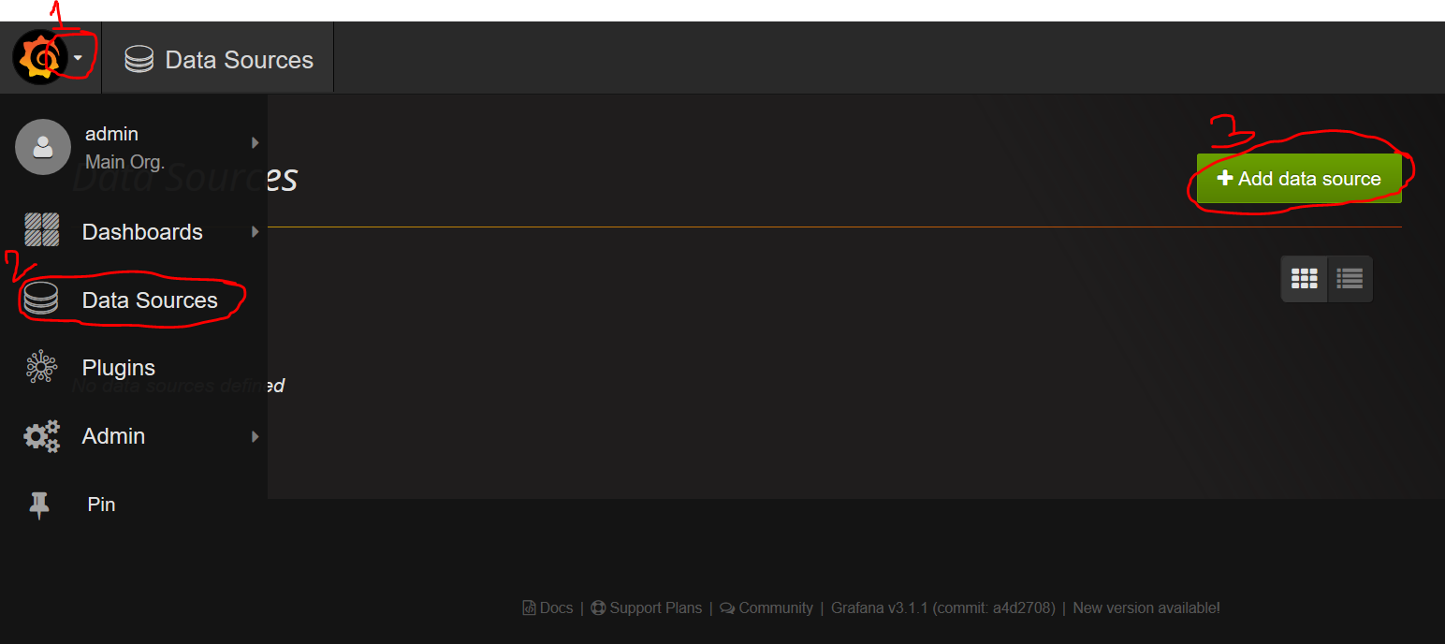

After clicked on “Add data source” 🡪 pop-up new windows.

Name: Prometheus, type: Prometheus, URL: Prometheus URL, Access: direct 🡪 then Click on “Add”.

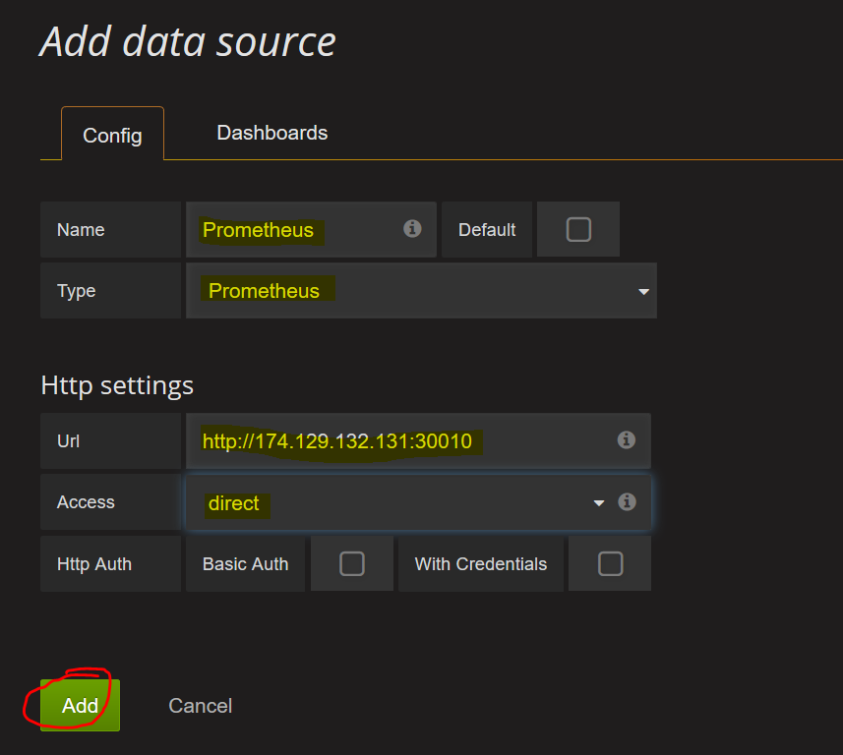

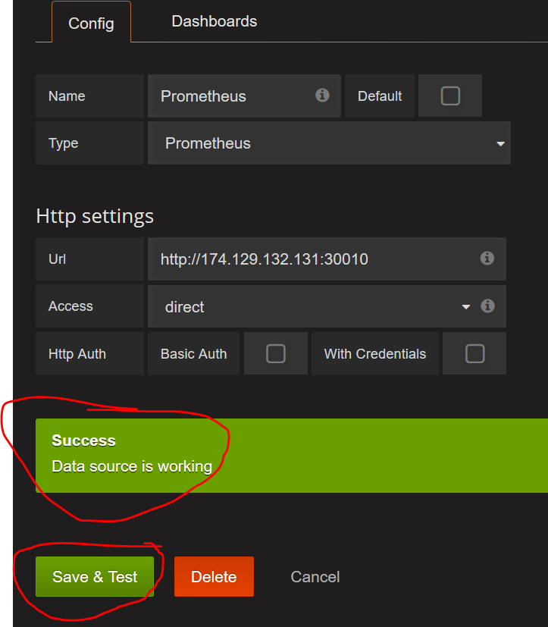

**NodeExporter**

**Note:** Repeat these steps on both your master and worker nodes.

1. Create the Prometheus user:

# adduser prometheus

1. Download Node Exporter:

# cd /home/prometheus

# curl -LO https://github.com/prometheus/node_exporter/releases/download/v0.16.0/node_exporter-0.16.0.linux-amd64.tar.gz"

# tar -xvzf node_exporter-0.16.0.linux-amd64.tar.gz

# mv node_exporter-0.16.0.linux-amd64 node_exporter

# cd node_exporter

# chown prometheus:prometheus node_exporter

1. Open “/etc/systemd/system/node_exporter.service” file and paste below content.

# vi /etc/systemd/system/node_exporter.service

[Unit]

Description=Node Exporter

[Service]

User=prometheus

ExecStart=/home/prometheus/node_exporter/node_exporter

[Install]

WantedBy=default.target

1. Reload systemd:

# systemctl daemon-reload

1. Enable the node_exporter service:

# systemctl enable node_exporter.service

1. Start the node_exporter service:

# systemctl start node_exporter.service

**Adding a Grafana Dashboard**

**Note:** You will import a Grafana Dashboard that will be used to visualize metrics imported from the NodeExporter. Below are the links to the dashboard.

Pre-request: download the Grafana Dashboard .json file from github.

**Step-1:** Adding a Grafana Dashboard.

Click on “menu bar” 🡪 select “DashBoards” 🡪 click on “import” 🡪 Then click on “upload .json file” and upload json file 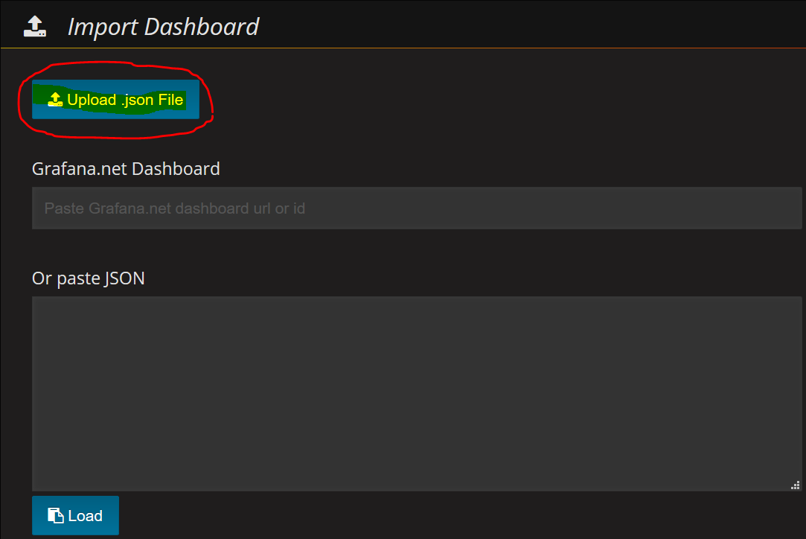

Step-2: After file uploaded 🡪 select the datasource name 🡪 finally click on “Save & Open”

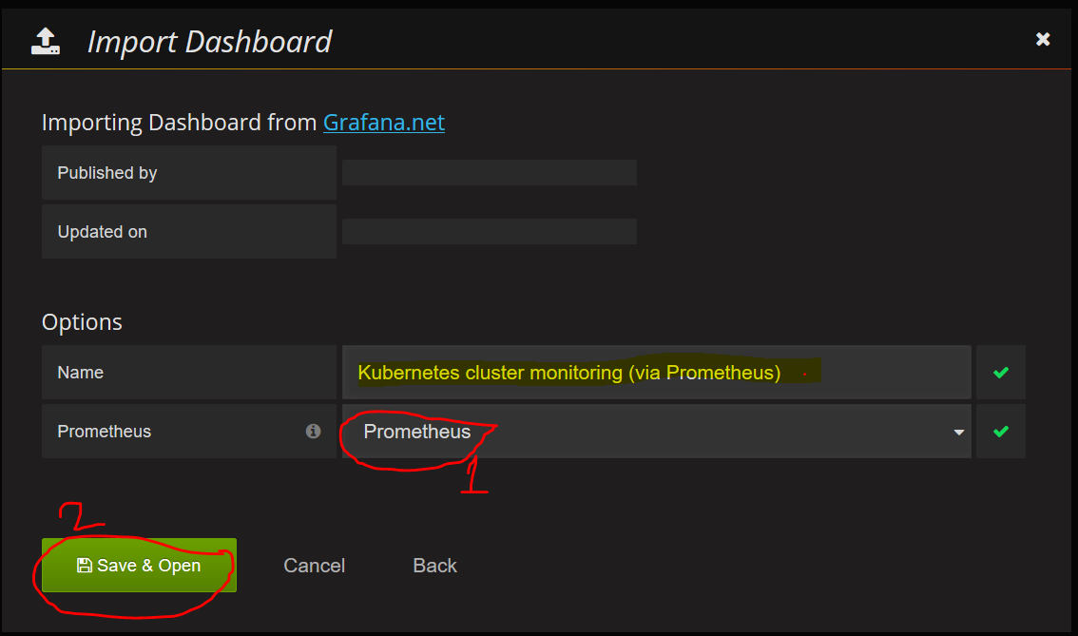

Step-3: Finally got Grafana Dashboard.

